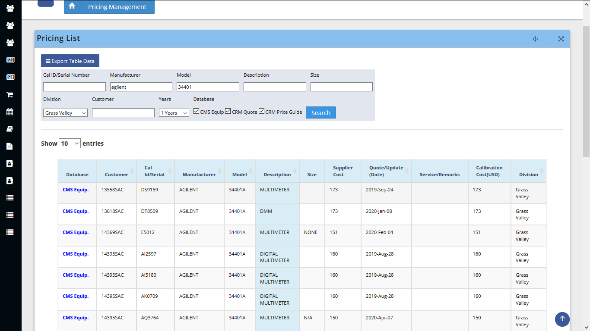

Three database

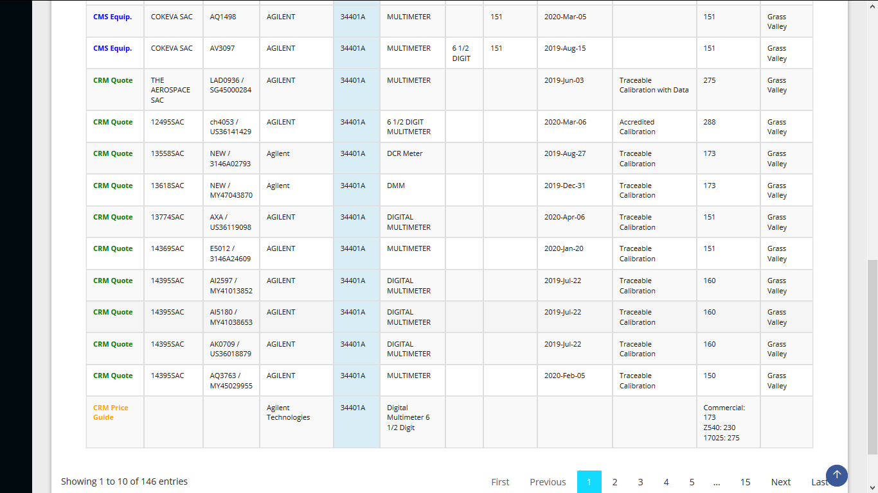

If you see the the Showing Entries 1 to 10 of 146, but the total rows on the first page or on the table shows 30.

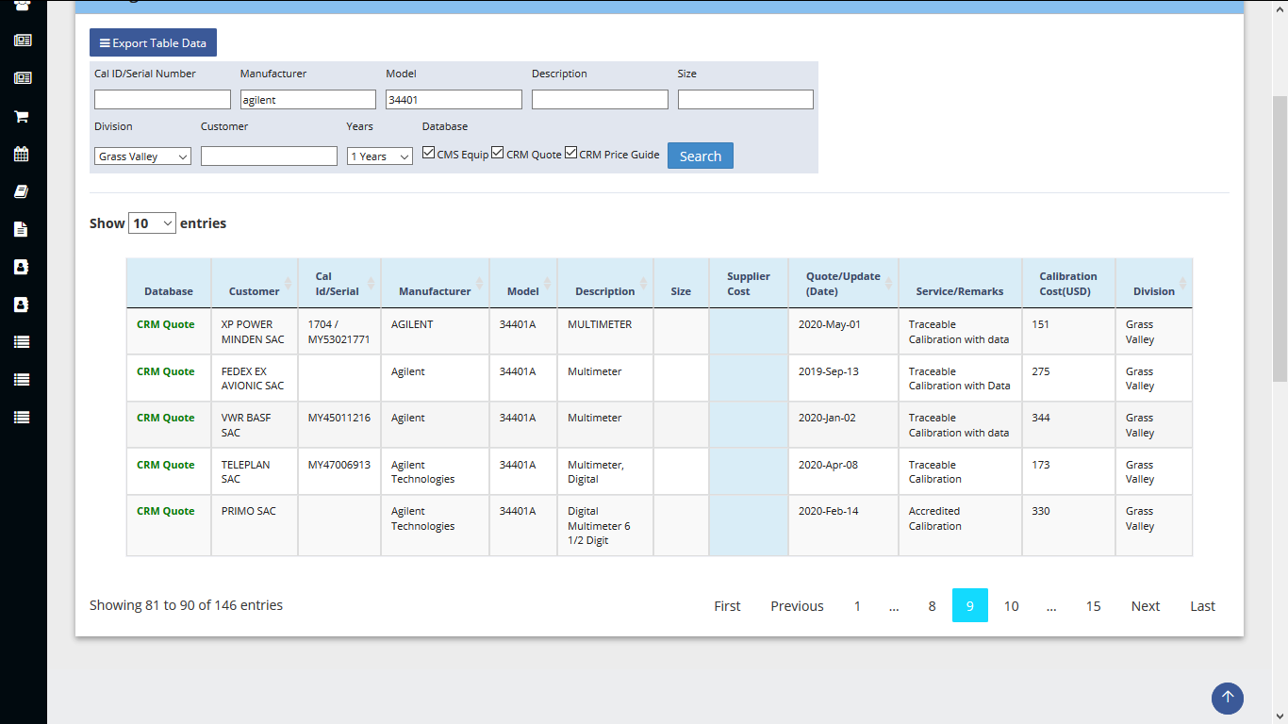

Page 9 is the last result on the table, From pagination page 10 to 15 there is no result.  
