Steps:

1. The below screenshot is from Tableau server site, where the Data Tables (bottom table in the screenshot) and the corresponding source table are both visible.

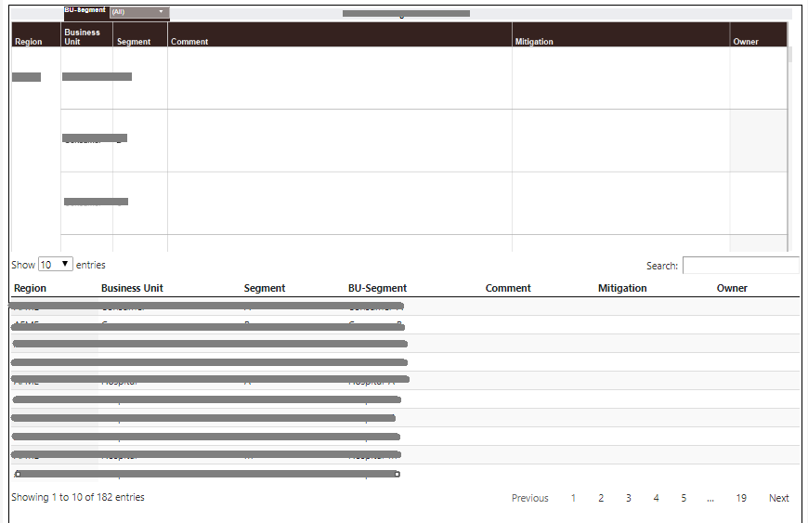

1. Next step is to download the Tableau workbook as an Image, PDF etc. As example I’m downloading as PDF.

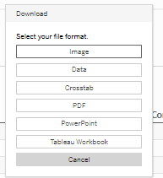

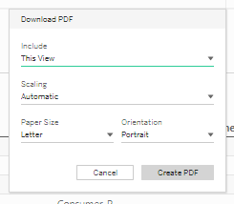

1. The workbook is downloaded as PDF and as you can see in the below screenshot Data Tables portion is appearing as blank. The same occurs when we export as an Image, PPT etc.

